**CREATION OF EXECUTABLE**

Navigation 🡺 System Administrator 🡪 Concurrent 🡪Program 🡪 Executable

Executable_name = XX_Create_Customer

Short_name = XX_Create_Customer

Application = Receivables

Execution_Method = PL/SQL Stored Procedure

Execution_File_Name = XXX_CUSTOMERS.MAIN

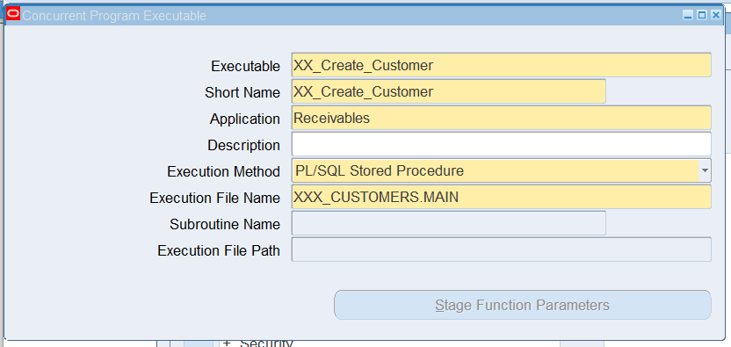

After this, click on **SAVE** button (which is at main menu OR Press **CTRL+S**)

**CREATION OF CONCURRENT PROGRAM**

Navigation 🡺 System Administrator 🡪 Concurrent 🡪Program 🡪 Define

Program_Name = XX_Create_Customer

Short_Name = XX_CREATE_CUSTOMER

Application = Receivables

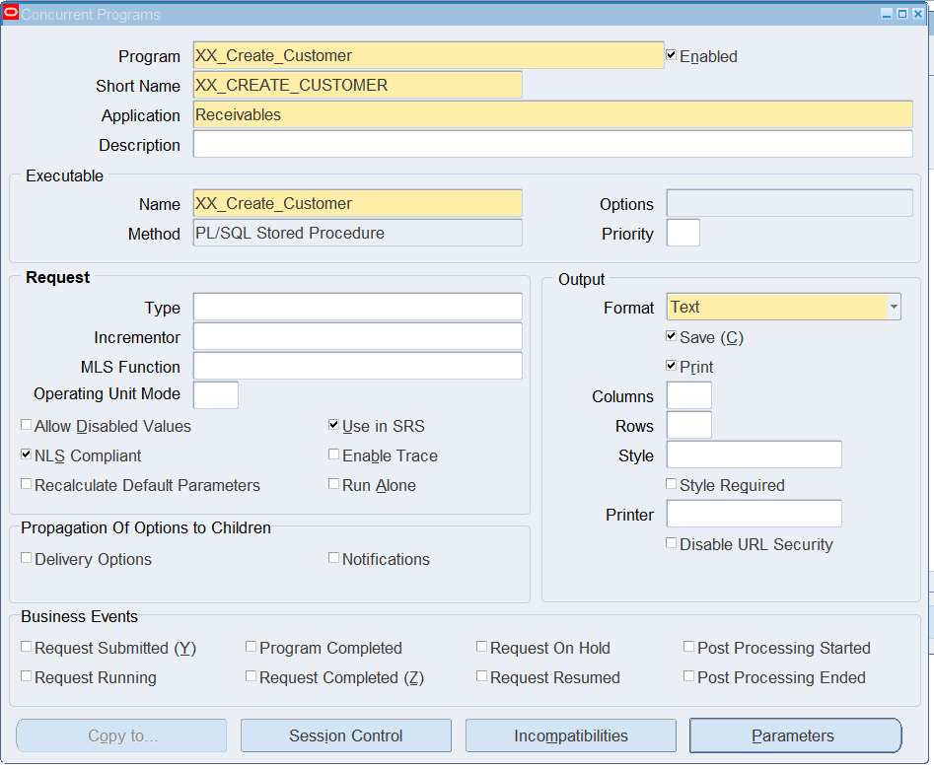

Then Click on Parameters button -> insert below parameters and its value sets.

**PARAMETERS** **VALUE SETS**

P_country 🡪 240 Characters Optional

p_address1 🡪 240 Characters Optional

P_CITY 🡪 240 Characters Optional

p_postal_code 🡪 240 Characters Optional

p_state 🡪 240 Characters Optional

P_organization_name 🡪 240 Characters Optional

P_site_use_type 🡪 240 Characters Optional

P_ACCOUNT_NAME 🡪 240 Characters Optional

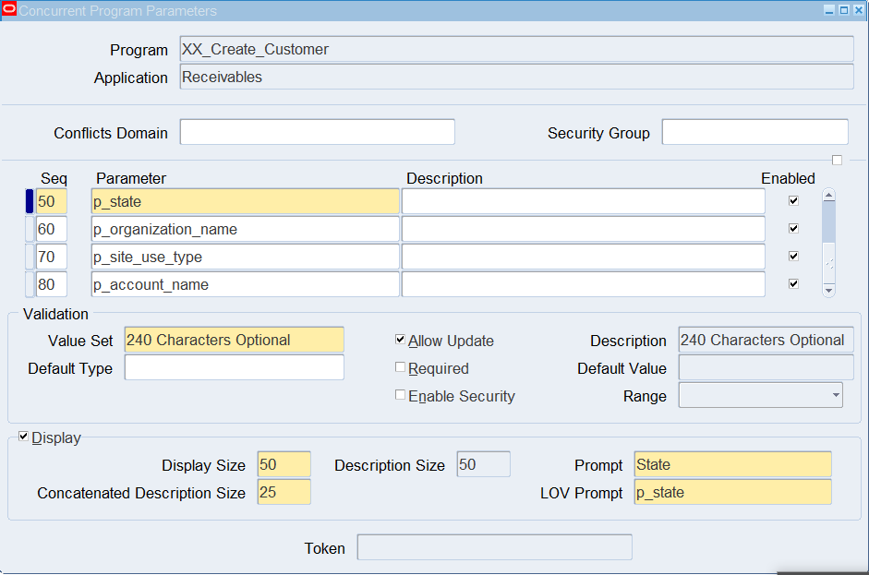

Then after filling all mandatory fields, then click on **SAVE** button (OR **CTRL+S**).

**ASSIGN TO REQUEST GROUP**

Navigation 🡺 System Administrator 🡪 Concurrent 🡪Security 🡪 Responsibility 🡪 Request

* In that window, we make it as query mode and mention **group** name as **Receivables All.**
* Then press CTRL+F11, In that we create a new line and insert our concurrent program name.
* Click on save Button (CTRL+S).

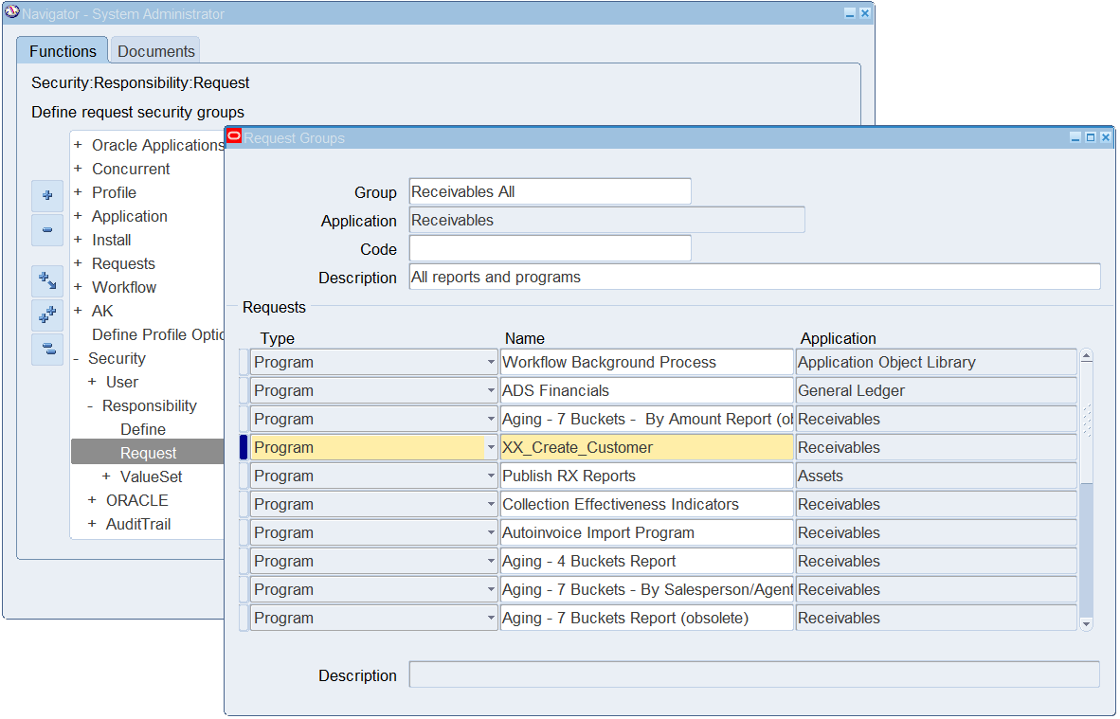

After Assigning to request group the navigate to respective assigned Responsibility

Navigation 🡺 Receivables, Vision Operations (USA) 🡪(Menu Bar) Views 🡪 request

Open a window in that click on **SUBMIT A NEW REQUEST**

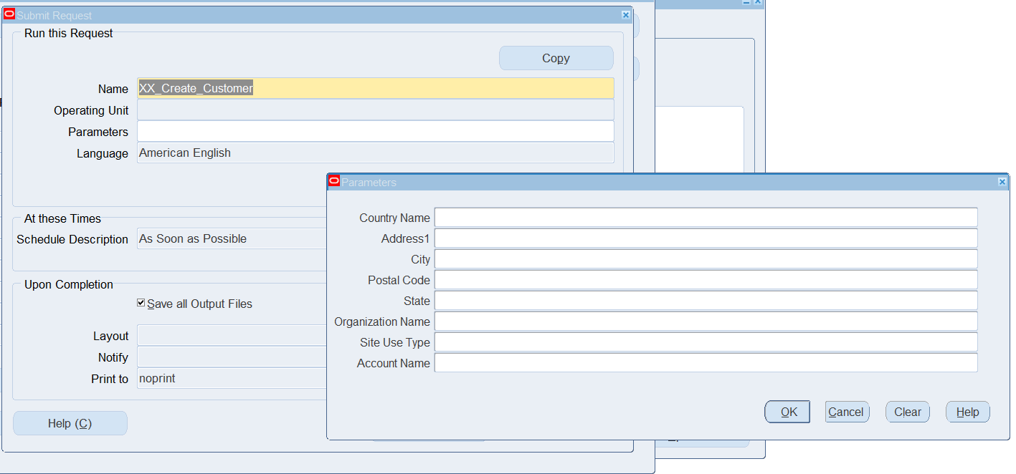

Fill all the parameter, like given below

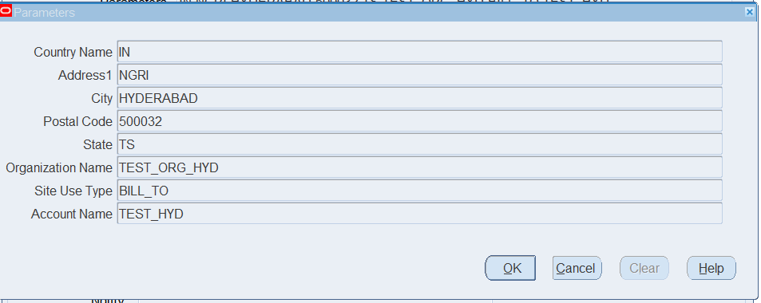

Then click on **OK.**

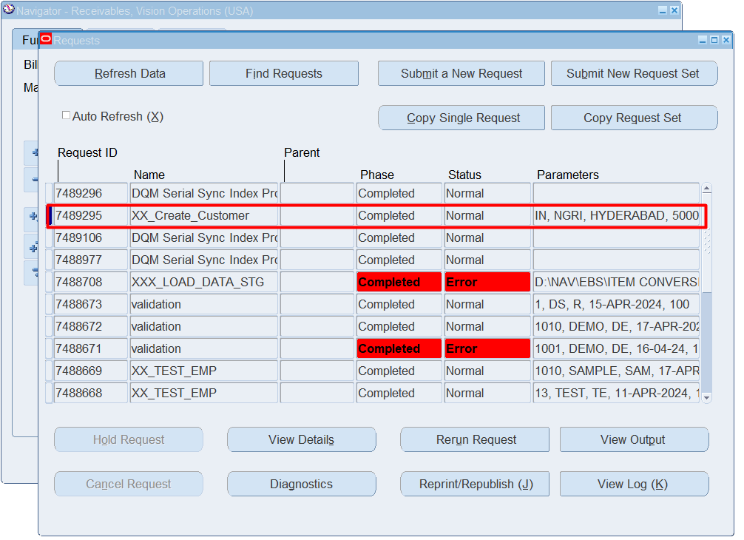

The concurrent program is successfully completed.

These are the details of the concurrent program which was executed successfully.

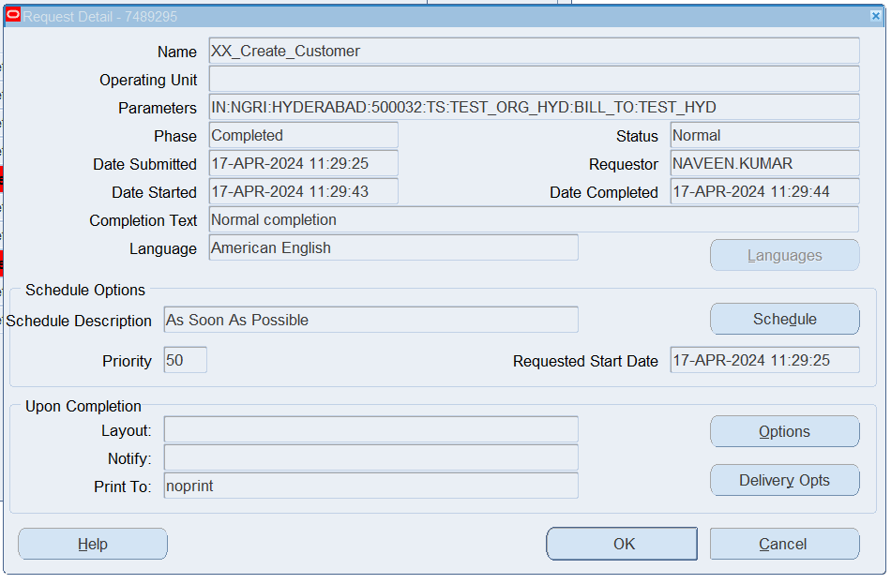

**Output for that Concurrent Program:**

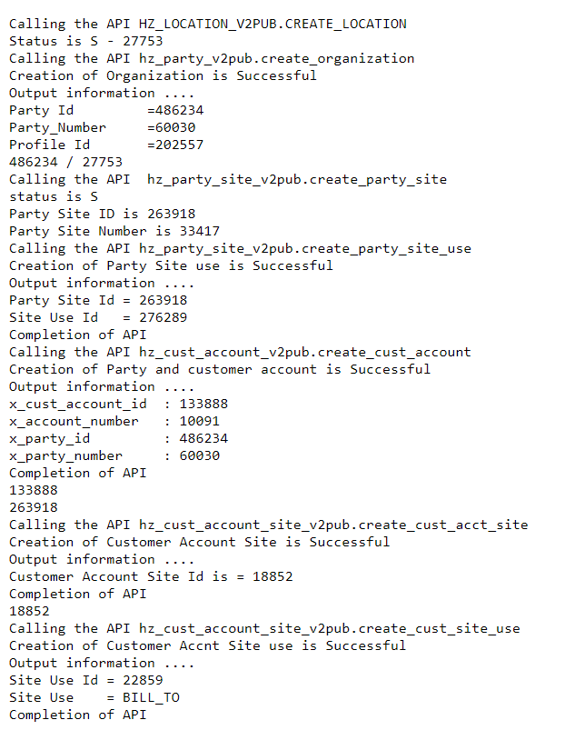

**SELECT * FROM HZ_LOCATIONS WHERE LOCATION_ID = 27753;**

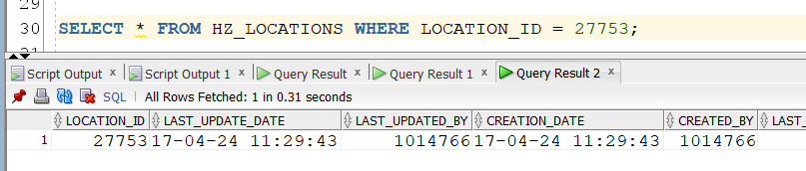

**SELECT * from hz_parties where party_id = 486234;**

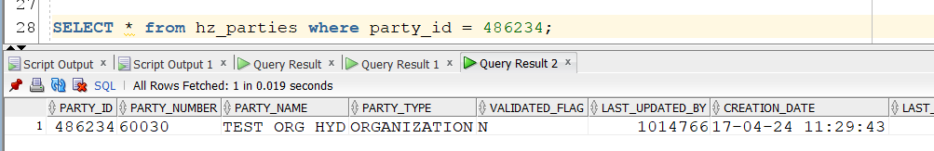

**select * from hz_party_sites where party_id = 486234;**

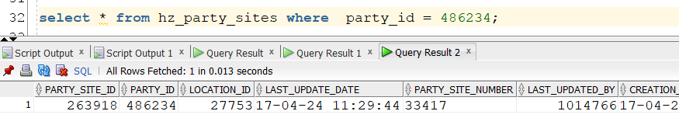

**select * from hz_party_site_uses where PARTY_SITE_ID = 263918;**

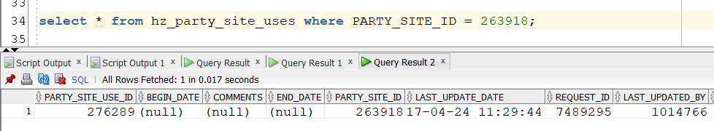

**select * from hz_cust_accounts where party_id = 486234;**

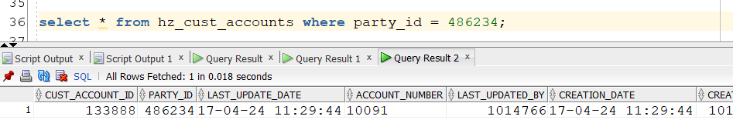

**select * from hz_cust_acct_sites_all where PARTY_SITE_ID = 263918;**

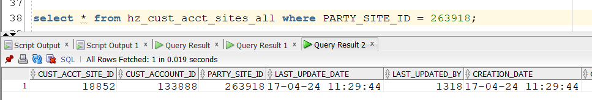

**select * from hz_cust_site_uses_all where cust_acct_site_id= 18852;**

